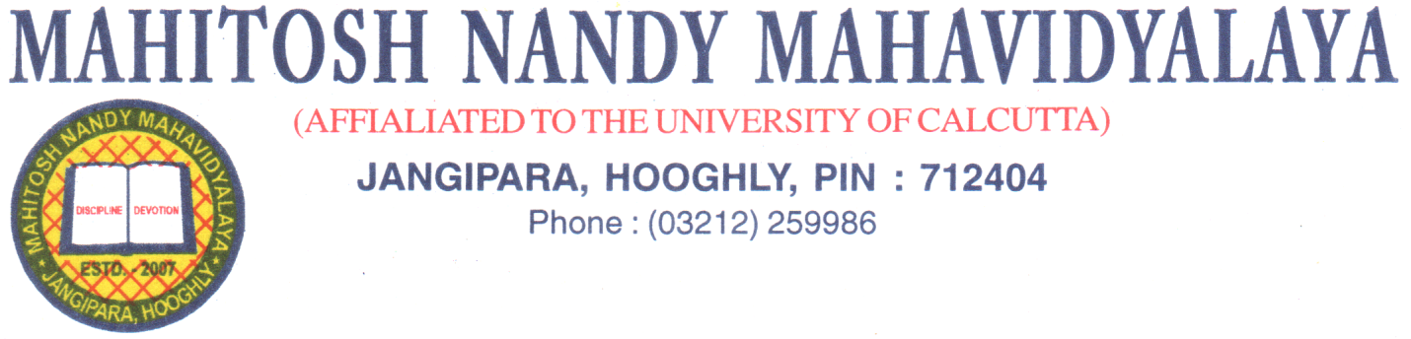
Dated: 18.11.21

College will remain closed on 19.11.2021 (Friday) due to Birthday of Guru Nanak.

By Order
Principal
Mahitosh Nandy Mahavidyalaya.

